For the buns:
350g flour
1 teaspoon salt
1 teaspoon mixed spice
1 teaspoon cinnamon
1 teaspoon nutmeg
50g sugar
50g butter
1 egg
25g currants (raisins)
40g mixed peel

hot cross buns
For yeast mixture:
1 tablespoon dried yeast
1 teaspoon sugar
50ml milk
150ml warm water
100g flour

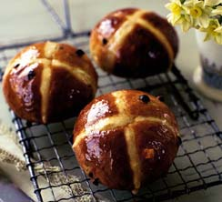

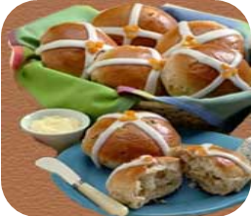

Instructions
Pour the warm milk and the warm water into a bowl.
Add the sugar, yeast and 100g of flour. Leave for 20 minutes in a warm place.
Sift 350g of flour, 50g of sugar, salt, mixed spice, cinnamon and nutmeg.
Melt the butter in a saucepan.
Beat the egg. Add the butter and the egg to the yeast mixture. Add the flour mixture, the currants and the mixed peel.
Stir the mixture well.
Knead the dough with your hands for 10 minutes.
Divide the dough into 12 pieces.
Place the buns on a baking tray.
Cover the buns with a towel. Leave in a warm place for 45 minutes.
For the topping, mix 1/2 cup (60 grams) of confectioners (powdered or icing) sugar and 1 tablespoon of milk or cream.
Place the glaze in a paper cone or a small plastic bag. Cut the end of the cone or bag and pipe a 'cross' on the top of each bun.
Put the buns in the oven (190°C). Bake for 15 to 20 minutes.

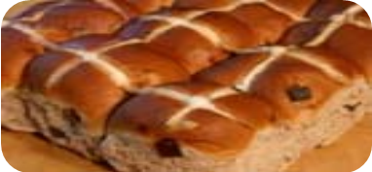
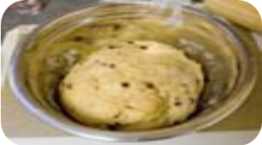

Source : Islcollective.com

